**ASSIGNMENT 3(BANKING SYSTEM)**

Database Design:

1. Create the database named "HMBank"

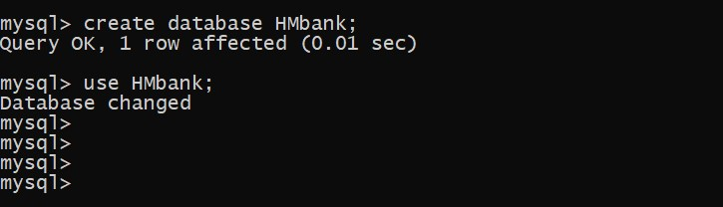

2. Define the schema for the Customers, Accounts, and Transactions tables based on the provided schema.

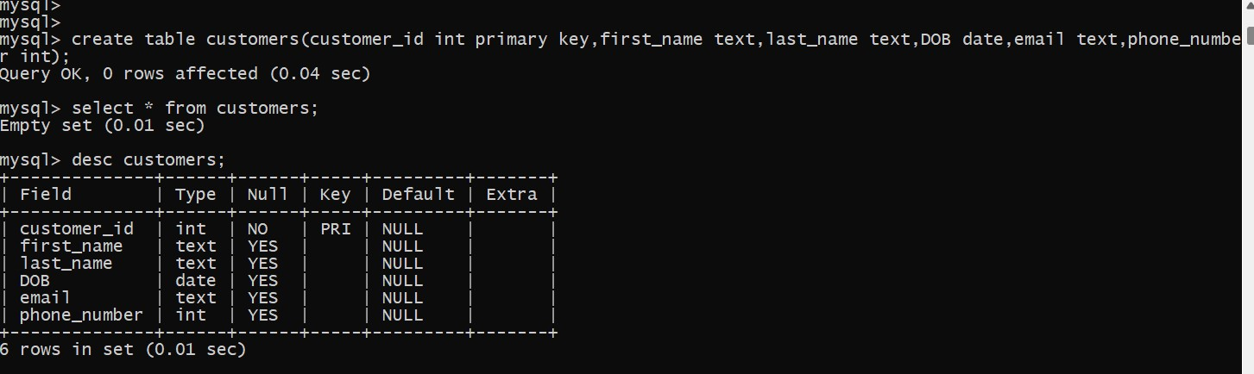

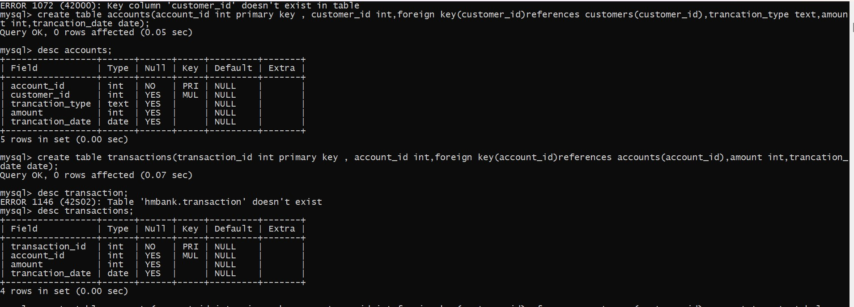

1. Insert at least 10 sample records into each of the following tables.

• Customers

• Accounts

• Transactions

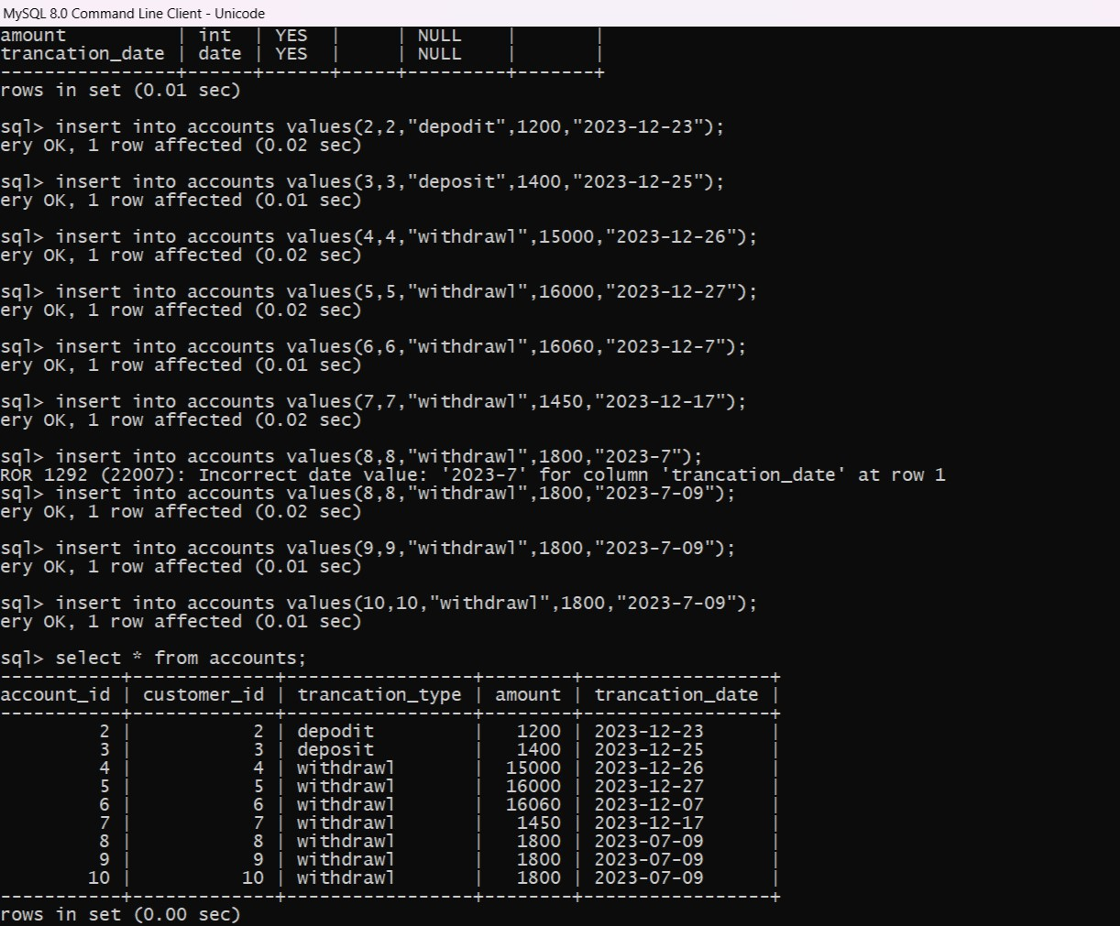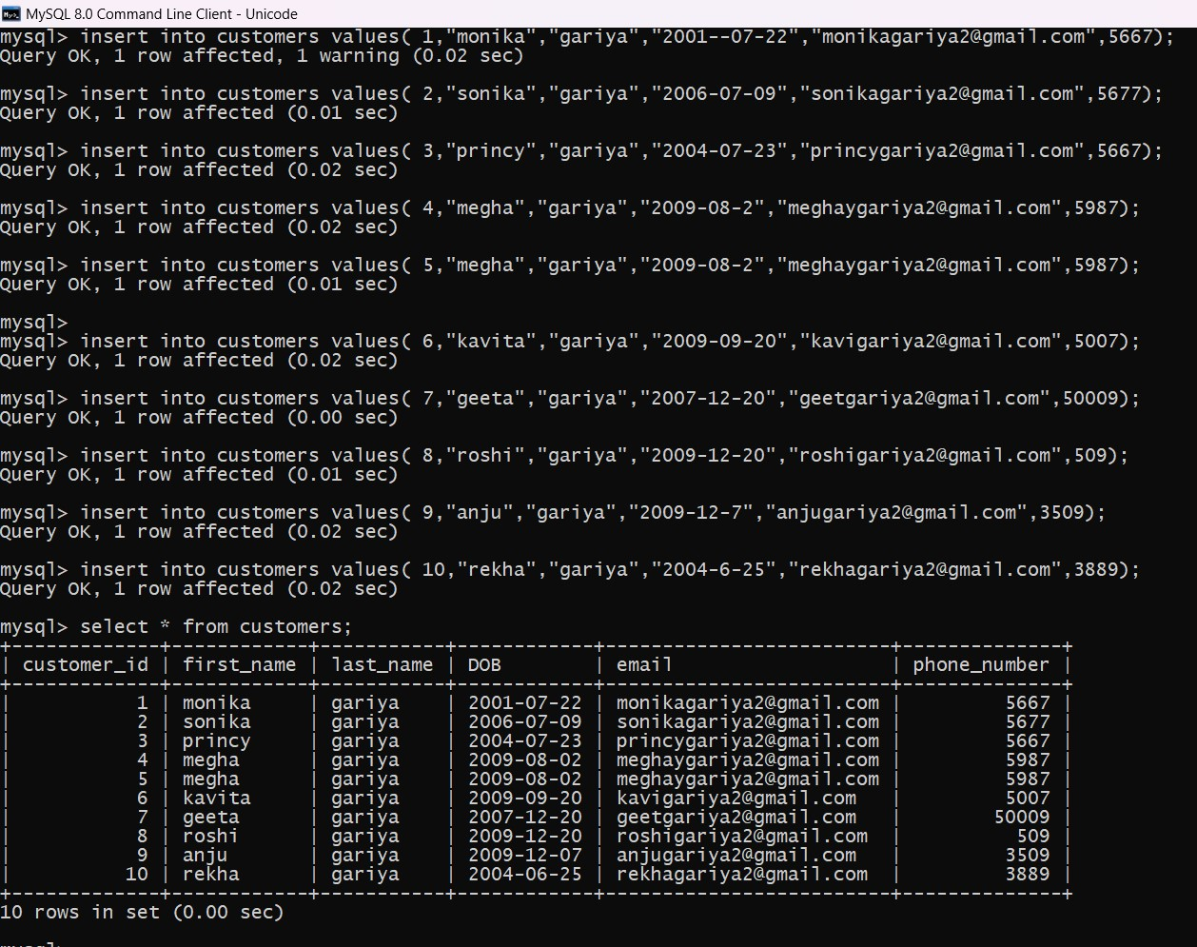

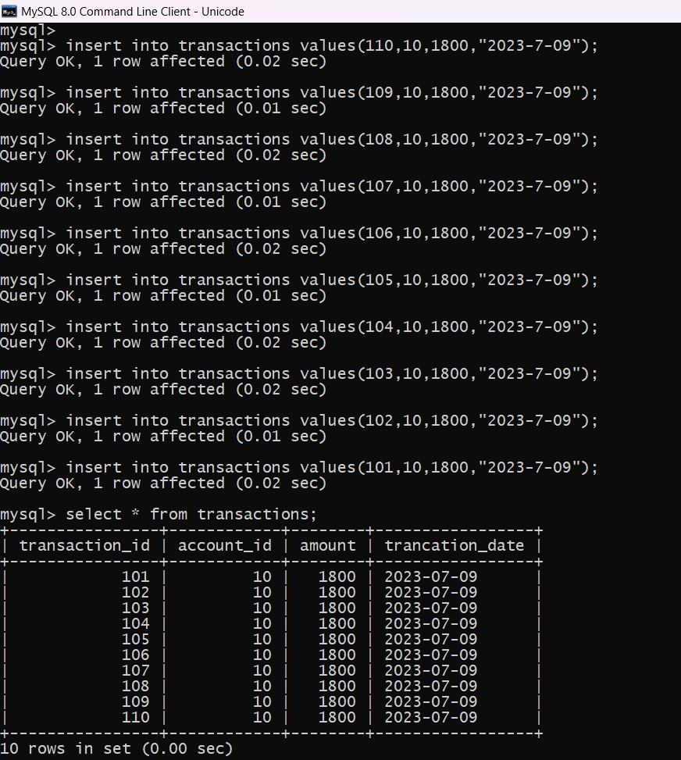

2. Write SQL queries for the following tasks:

1. Write a SQL query to retrieve the name, account type and email of all customers.

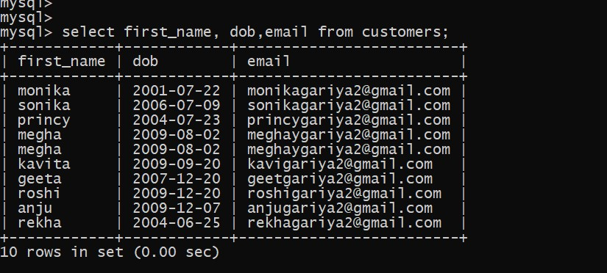

2)Write a sql query to increase the amount of a specific account by certain amount.

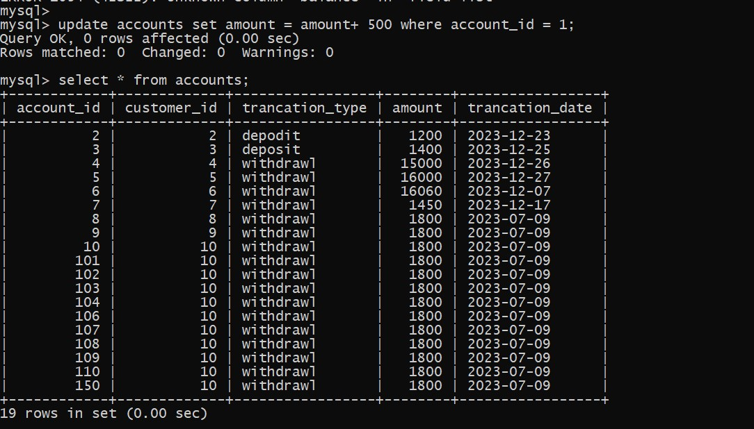

3)Write a sql quer to combine first and last name of customers as a full_name,

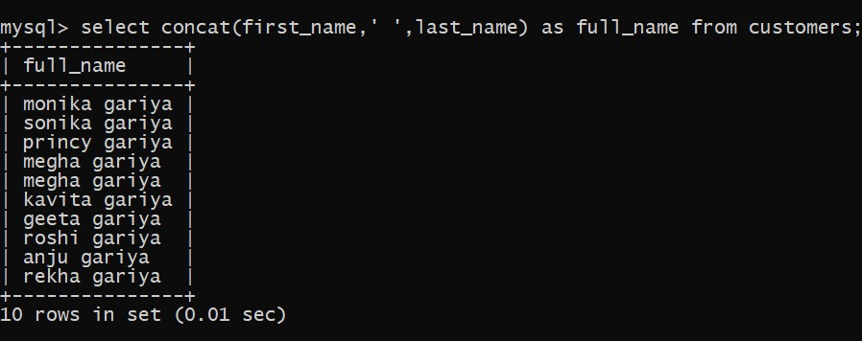

4) write a sql query to remove accounts with a balance of zero where the acxcount type is withdrawl

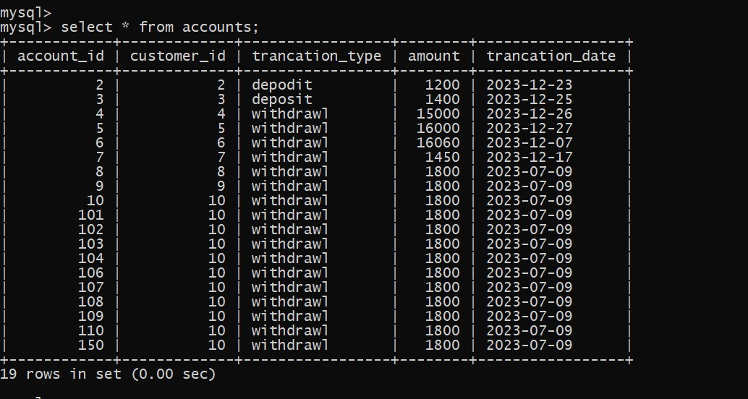

5) write a sql query to find customer of specific name.

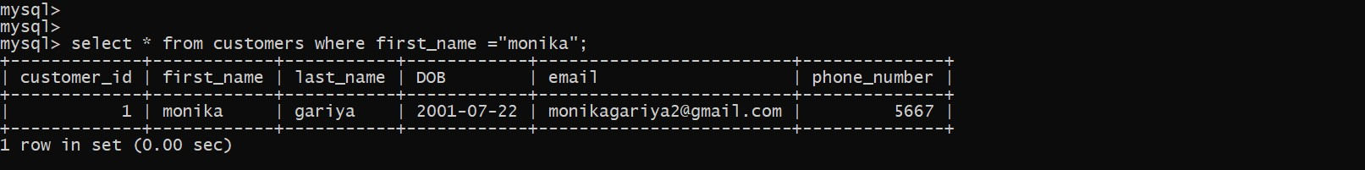

6) write a sql query to get the account for a specific account.

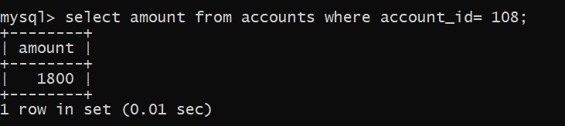

7)write a sql query to list all account with a balance greater then 1200.

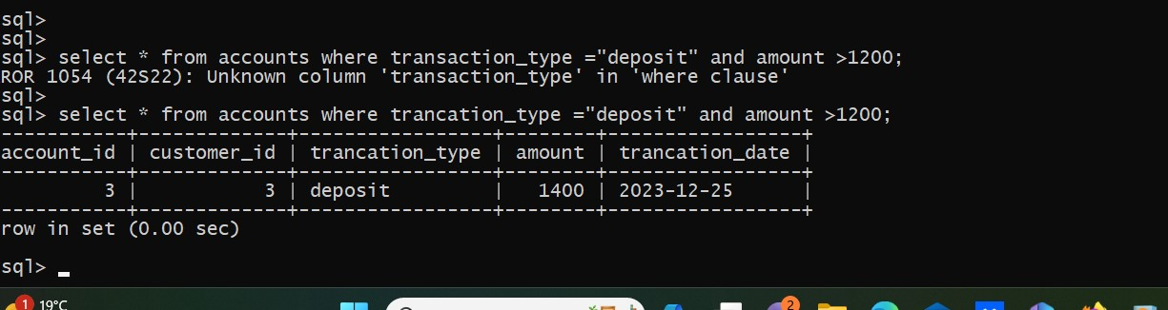

8) write a sql query to retrieve all transaction for a specific account.

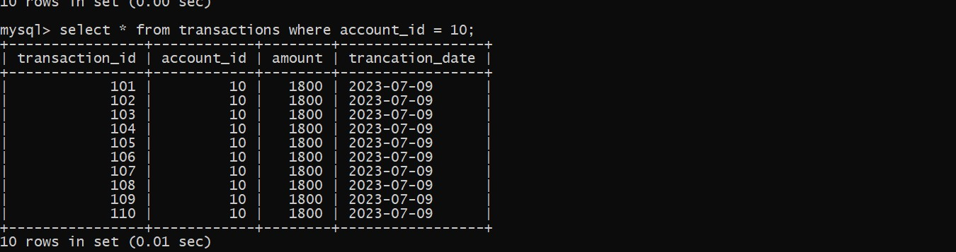

9)write a sql query to identify accounts where the balance is less then 1800;

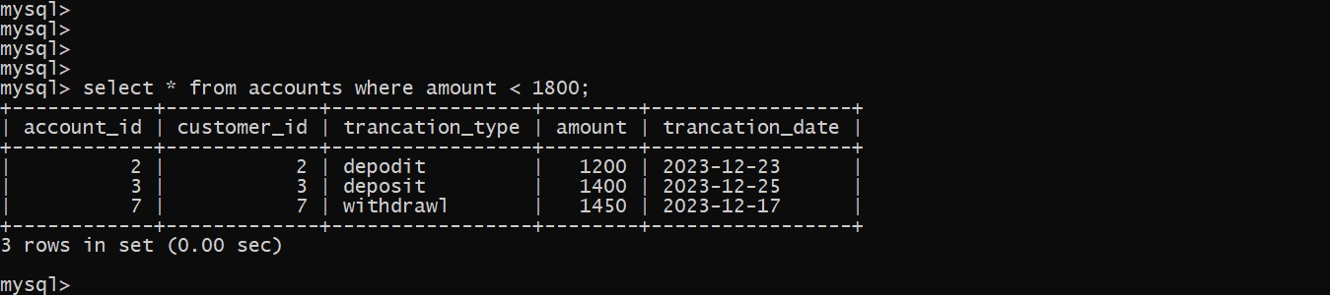

10) write a sql query to find customer first name is megha;



Tasks 3: Aggregate functions, Having, Order By, GroupBy and Joins:

1. Write a SQL query to Find the average account balance for all customers.

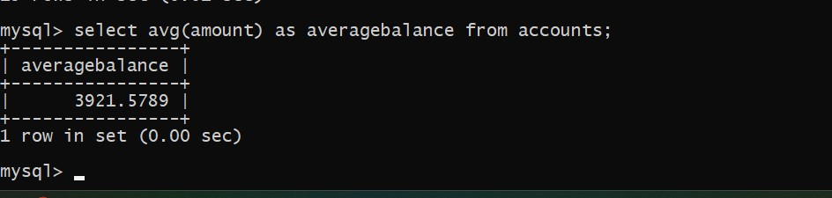

1. Write a SQL query to Retrieve the top 10 highest account balances.

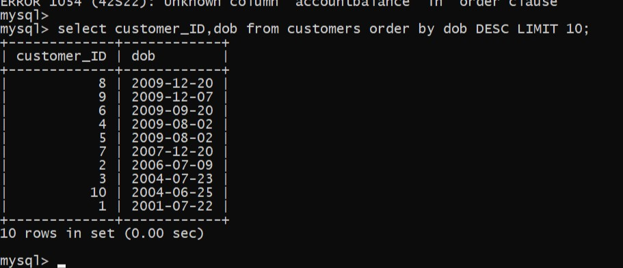

1. Write a SQL query to Calculate Total Deposits for All Customers in specific date.

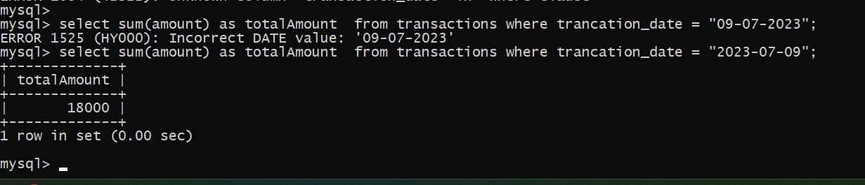

1. Write a SQL query to Find the Oldest and Newest Customers.

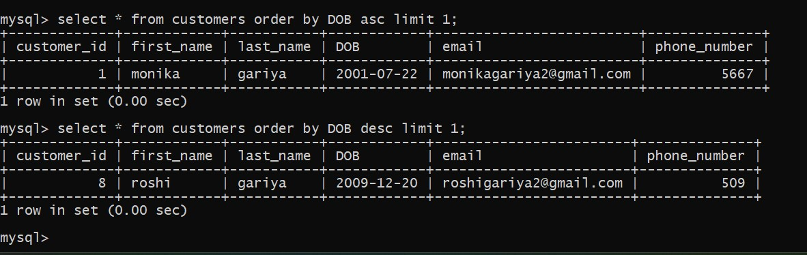

1. . Write a SQL query to Retrieve transaction details along with the account type.

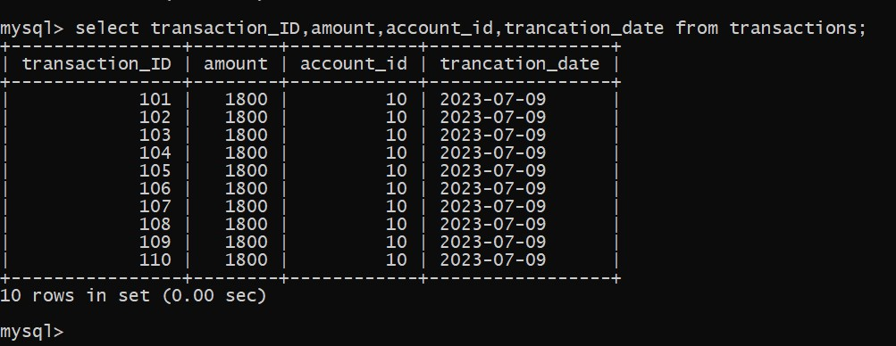

1. Write a SQL query to Get a list of customers along with their account details.

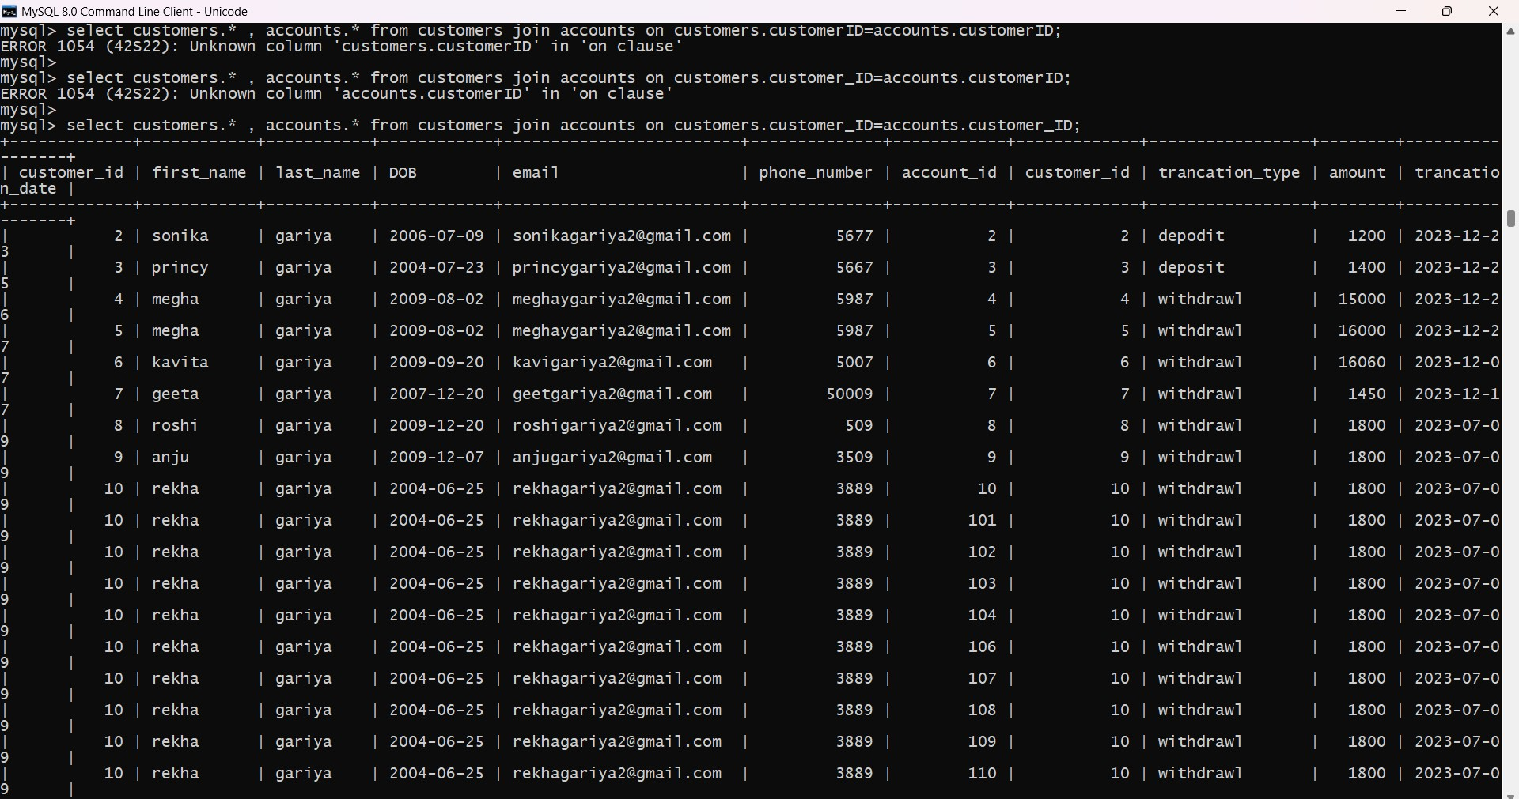

7. Write a SQL query to Retrieve transaction details along with customer information for As specific account.

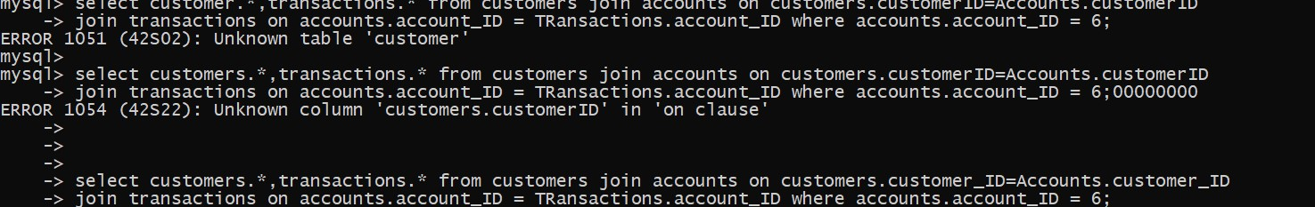

8.Write a SQL query to Identify customers who have more than one account.

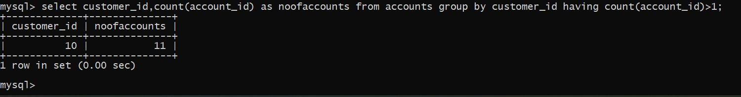

9.  Write a SQL query to Calculate the difference in transaction amounts between deposits and withdrawals.

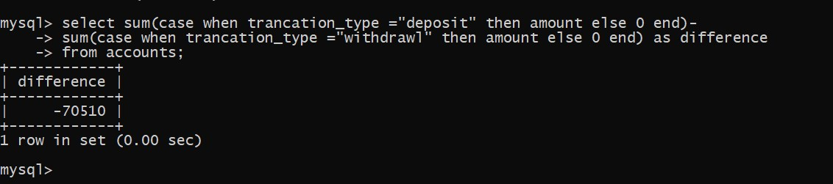

10. Write a SQL query to Calculate the average daily balance for each account over a specified period.

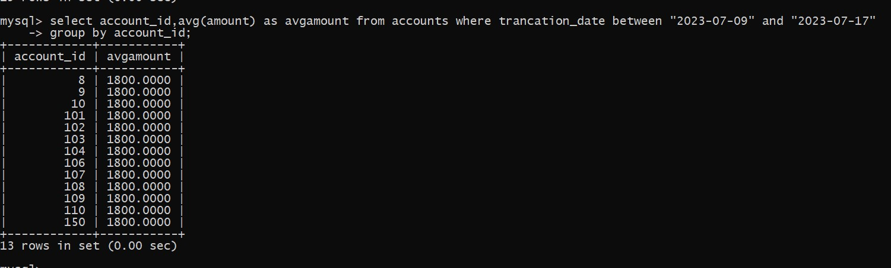

Subquery and its type:

1. Retrieve the customer(s) with the highest account balance.

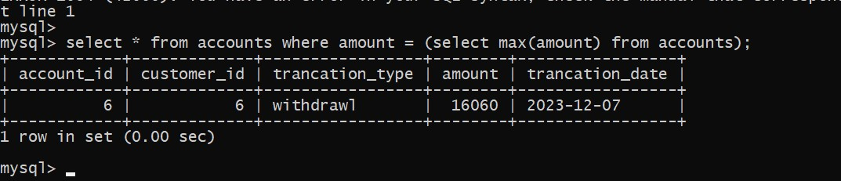

1. Calculate the average account balance for customers who have more than one account

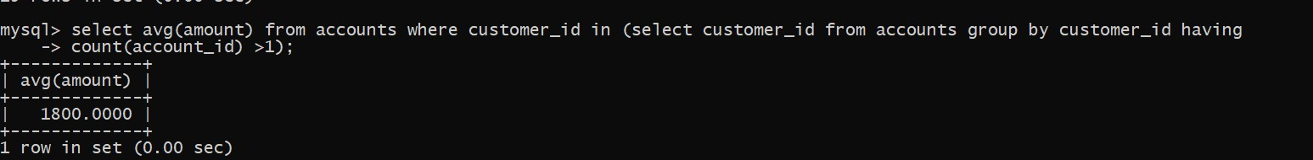

1. . Retrieve accounts with transactions whose amounts exceed the average transaction amount



1. Identify customers who have no recorded transactions.

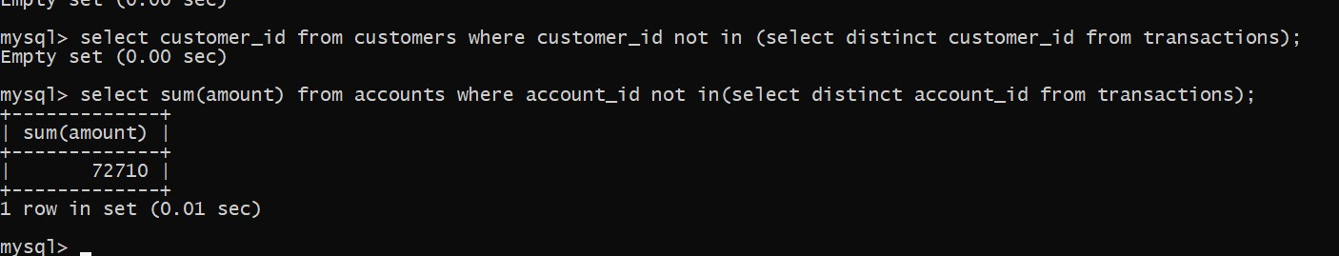

1. Calculate the total balance of accounts with no recorded transactions



9. Retrieve all transactions for a customer with a given customer_id

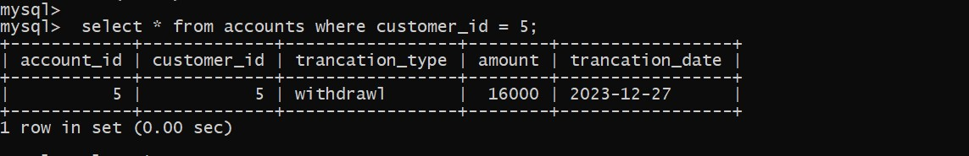

10. Calculate the total balance for each account type, including a subquery within the SELECT clause.

